

LCE 2.0 – Technical Specification
(Backend + New Users Backend)

Version: Draft 1

0. Purpose & Scope
1. Product Overview
2. Website & User Flows
3. Scheduling & Service Model
4. Data Model (MySQL)
5. Business Logic
6. Users Backend (Admin / CSR Portal)
8. Migration & Backwards Compatibility
9. Non-Functional Requirements
10. Implementation Checklist (High-Level)

0. Purpose & Scope
This document defines the functional and technical specification for Laundry Care Express 2.0, including:
- New consumer offerings:
    - Pay per Order (PPO by the pound)
    - Subscribe & Save (Subscription by the bag)
- Customer website flows (public site + logged-in experience)
- Scheduling model (One Time Service / Weekly (Bi-Weekly))
- Subscription logic (bag banking, overages, annual discount, etc.)
- Pricing model and integration with existing price lists
- Order, invoice, transaction, and promo handling
- A new Users Backend (Admin/CSR dashboard) for internal staff
- Required changes and additions to the existing MySQL schema and backend APIs
The goal: a single source of truth that backend, frontend, and mobile engineers can implement from.

1. Product Overview

1.1 Offer Types

1. Pay per Order (“PPO”)
- Audience: Residential and commercial “pay-as-you-go” customers.
- Pricing:
    - Base W&F Rate: $2.99 / lb (configurable).
    - Minimum: $30 of laundry (~10 lbs), plus:
    - P&D fee: $9.99
    - Service fee: $5.00
    - So the minimum order total is $* for next-day turnaround.
- Fees:
    - P&D (Pickup & Delivery): $9.99 per order.
    - Service fee: $5.00 per order.
    - Both should be configurable via database.
- Turnaround:
    - Standard next-business-day for W&F.
- Individually priced items:
    - Wash and Fold - Individual Items (WF)
    - Dry cleaning (DC)
    - Hang dry (HD)
- No-laundry fee:
    - Existing “no laundry fee” is effectively replaced with P&D fee; logic must support charging P&D if driver shows up and no clothes.

2. Subscribe & Save (Subscription by the Bag)
- Subscription plans (per month, 1 bag = ~20–21 lbs):
    - 1 bag / month: $70
    - 2 bags / month: $67 per bag
    - 4 bags / month: $65 per bag
    - 8 bags / month: $64 per bag
    - Prices configurable; those values are defaults.
- Bag details:
    - ~2948 cubic inches (roughly 20 gallon bag), about 21 lbs capacity baseline used for modeling.
- Overages:
    - If bag weight > capacity threshold (e.g. 20–21 lbs), the “overage” lbs are charged at PPO per-lb rate.
    - If number of bags per month > plan bag count, extra bags are charged at per-bag subscription rate (plan-level rate).
- Banking:
    - Unused bags can be banked and carried over as long as subscription remains active.
- Annual subscription:
    - Annual prepay discount: 15% off monthly pricing.
    - Early cancellation: pro-rated refund with 15% fee, minimum $100.
- Fees:
    - No P&D or service fees for subscription orders. (“Subscriptions waive all P&D fees, Service Fees.”)
- Included items:
    - W&F in subscription bags is included.
    - Individual DC/HD/LP items:
- Included if they fit in the bag (exact rules may be clarified at implementation).
- If they don’t fit, they are charged per price list (PPO logic).
- Scheduling:
    - Subscription customers can schedule:
- One Time Service - next available pickup or any day in the future
- Weekly (Bi-Weekly) - recurring pickups

1.3 Up-Front Promotions & Credits
- New user pop-up on home page:
    - Offers $20 credit, added to user account after signup.
- Promo codes:
    - Existing promo code structure is reused, plus new types for subscription offers where needed.

1.4 Turnaround & Operations
- Operating days: Mon–Fri initially (configurable), with potential for Sat later.
- Turnaround:
    - Subscription: same as PPO for W&F; DC/HD may have longer turnaround (configurable).
- Laundry handling:
    - Cold water only, medium heat dryers by default.
    - DC/LP items handled according to price list instructions.
- Labeling:
    - Wash and Fold (WF): flagged and returned in WF bag.
    - Hang Dry (HD): flagged and returned in HD bag.
    - Dry Cleaning (DC): flagged and returned in DC bag.

2. Website & User Flows

2.1 Navigation (Public Website)
From “LCE 2.0 Public Website navigation”.
https://docs.google.com/drawings/d/1ub4Xxd2e7o8B_4j2XHcbaULDa4tKHVJZvGKQeNRf1GU/edit

2.2 Core Signup & Onboarding Flow
Goal: new user goes from website to scheduled pickup in 3 steps.

Step 1 – Account Creation (“Step 1 of 3”)

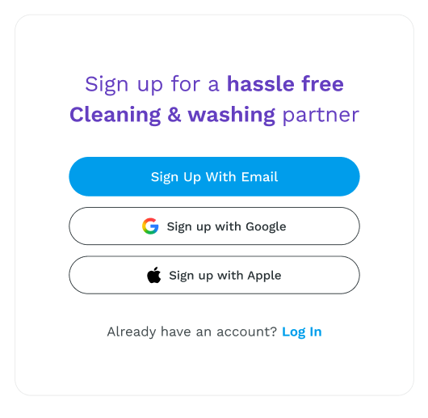
- User sees signup with:
    - Sign up with Email
    - Sign up with Google
    - Sign up with Apple
    - “Already a customer? Login” link.
- If email:
    - Form fields:
    - First name
    - Last name
    - Mobile phone
    - Email
    - Password
    - Accept terms & privacy policy
      - By selecting continue, you agree to receive service and marketing auto-sent texts from Rinse. Opt-out anytime on your “My Account” page or text “STOP”. Message frequency varies. Message & data rates may apply. By continuing, you also agree to our Terms and Privacy Policy.
          - Create User (auth) + Customer profile records.
          - Apply $20 new-user credit (if eligible).
          - Create session and move to Step 2.

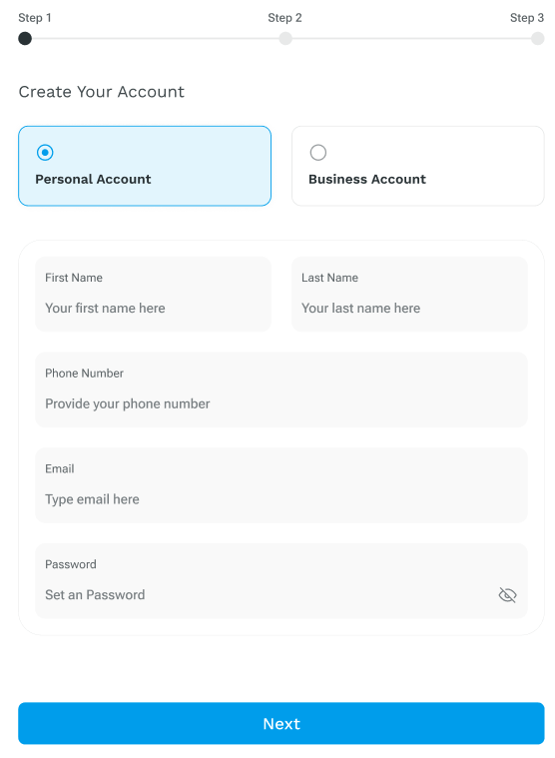

Step 2 – Address & Serviceability (“Step 2 of 3”)

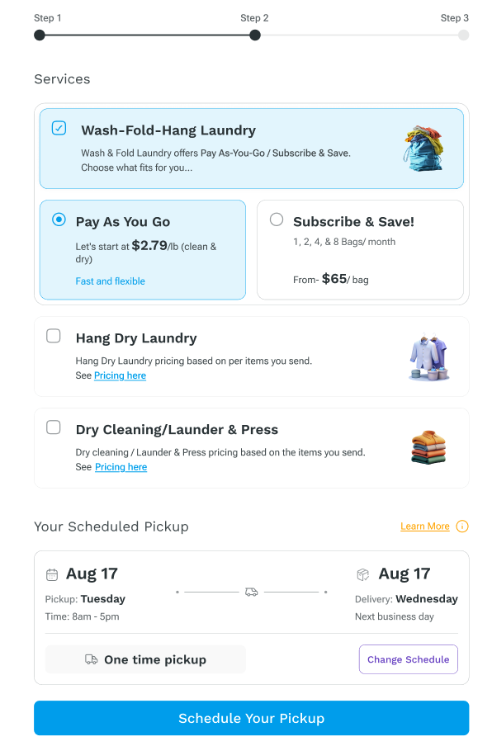

Step 3 – Scheduling (“Step 3 of 3”)

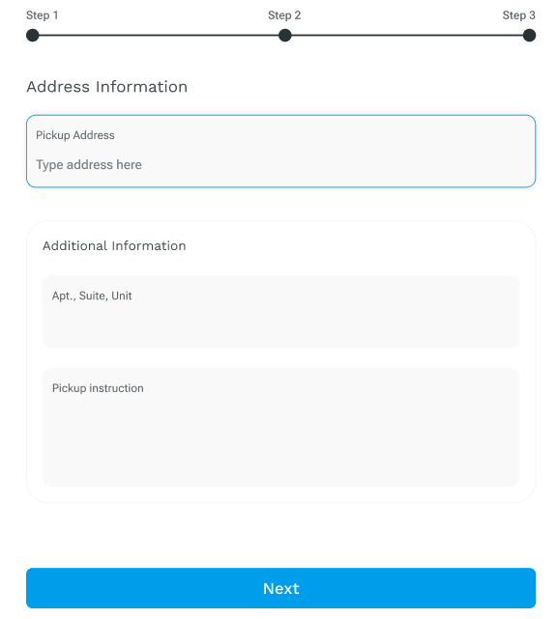

2.3 Returning User Flows (Web/App)
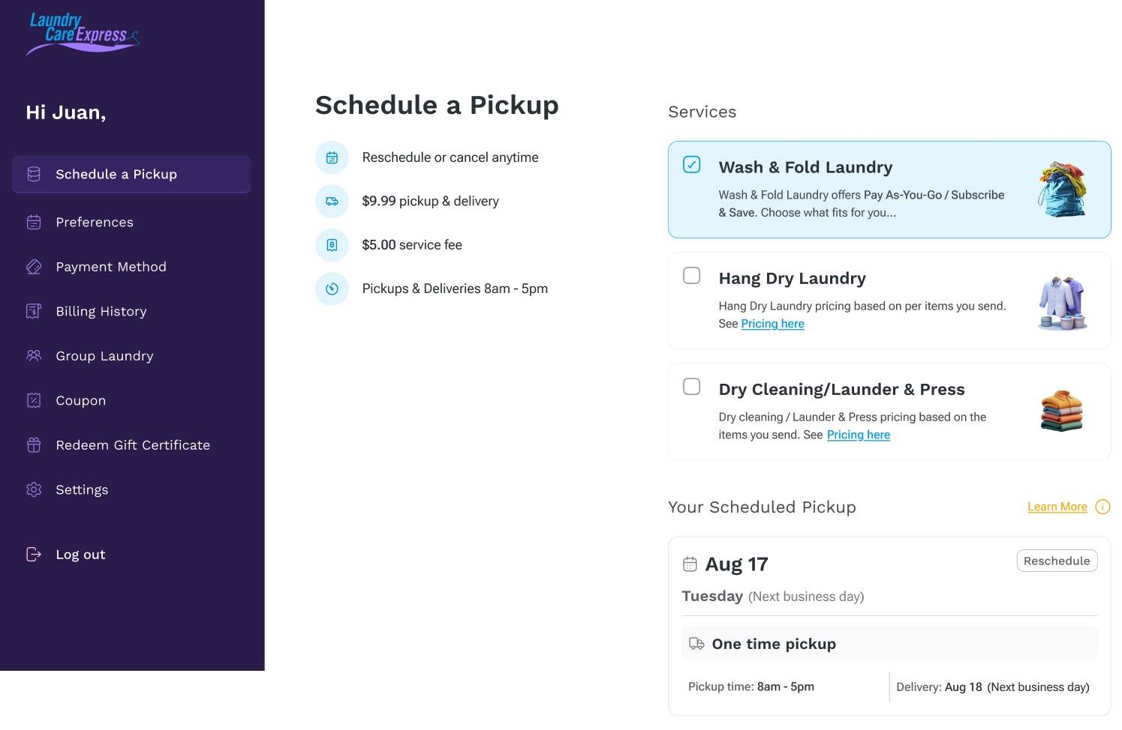

3. Scheduling & Service Model

3.1 Scheduling Matrix Summary
From Scheduling Matrix sheet:
- LCE 1.0:
- PPO by pound (existing).
- SCHEDULING:
  - One-time (ASAP/future).
  - Weekly (Bi-weekly) for all customers.
- LCE 2.0:
- For Residential & Commercial:
  - Payment types:
    - PPO (By the Pound) with P&D + service fee.
    - Subscription (By the Bag, no fees).
  - SCHEDULING:
    - For new customers:
      - One-time (ASAP/future).
      - (Bi-)Weekly recurring.
  - Note 1 (Overages):
    - Overages charged by the pound at PPO rate.

3.2 Scheduling Rules
- ASAP:
  - Choose earliest available date given:
    - Zone service days (Mon–Fri).
    - Non-working days / holidays (see DB).
    - Daily cutoff time (configurable).
- Future date:
  - Customer can choose any available date on scheduling calendar.
  - Calendar must exclude:
    - Non-service days for user’s zone.
    - Non-working days/holidays.
- Weekly (Bi-weekly) recurring:
  - User chooses:
    - Weekly or Bi-Weekly
    - Day of week (within zone service days).
  - System creates recurring schedule record for user.
  - Upcoming pickups generated automatically as events.

4. Data Model (MySQL)
The current production schema is in lce_site database. Key existing tables (abbreviated):
- f29om_users – Legacy Auth users (email, password, block, etc.)
- lce_user_info – Customer details, contact info, addresses, payment, preferences.
New Fields: Auth users (email, password, block, etc.)
- lce_pickup_zones – Zones by ZIP/city/state + days of operation + geometry.
- lce_pickup_nonworking_days, lce_holidays_logs – Non-working days and any holiday email logs.
- lce_prices, lce_prices_lists – Price lists and items.
- lce_processing_sites – Processing facilities and and price list assignments.
- lce_user_pickup – Core pickup/order record (per pickup).
- lce_user_invoice, lce_user_invoice_line – Invoice header and lines.
- lce_user_transactions, lce_payment – Transaction and payment logs.
- lce_promo_codes, lce_user_promocode, lce_user_promocodes – Promo definitions and usage.
- lce_user_rs – Recurring schedule.
- lce_user_cs, lce_user_cs_log – Customer service tickets and logs.
- lce_user_group_* tables – Group admin, members, logs, and history.
- lce_communication_settings – Email/SMS communication preferences.
- lce_users_vacation_logs – Vacation holds.
- lce_waiting_list, lce_tmp_* tables – Waiting list and temp data.

4.1 High-Level Entity Model
New and existing entities:
- UserAuth
  - Backed by lce_user_info.
  - Fields: id, name, username (email), password hash, block, registerDate, lastvisitDate, etc.
- CustomerProfile
  - Backed by lce_user_info.
  - Contact info, primary address, billing address, payment profiles, preferences, price list, etc.
- PickupZone
  - Backed by lce_pickup_zones.
- Order / Pickup
  - Backed by lce_user_pickup.
- Invoice and Invoice Line
  - lce_user_invoice, lce_user_invoice_line.
- Transaction
  - lce_user_transactions, lce_payment.
- PriceList / PriceItem
  - lce_prices_lists, lce_prices.
- Promo & Credit
  - lce_promo_codes, lce_user_promocode.
- SubscriptionPlan (NEW)
- UserSubscription (NEW)
- SubscriptionBagUsage (NEW)
- UserCredits (NEW or extension of transactions)
- CommunicationSettings
  - lce_communication_settings.
- RecurringSchedule
  - lce_user_rs.
- VacationHold
  - lce_users_vacation_logs.
- GroupAccount
  - lce_user_group_admin, lce_user_group_members, lce_user_group_members_history.

4.2 Required New Tables
Below are proposed new tables (names and columns are suggestions; adjust as needed).

4.2.1 lce_subscription_plans
Stores configuration for subscription plans (Subscribe & Save).
CREATE TABLE lce_subscription_plans (
id INT AUTO_INCREMENT PRIMARY KEY,
code VARCHAR(32) NOT NULL, -- e.g. 'SUB_M_1BAG', 'SUB_A_2BAG'
name VARCHAR(64) NOT NULL, -- e.g. 'Subscribe & Save – 1 Bag'
bags_per_month INT NOT NULL, -- 1, 2, 4, 8
price_per_bag DECIMAL(10,2) NOT NULL,
billing_cycle ENUM('monthly','annual') NOT NULL DEFAULT 'monthly',
annual_discount DECIMAL(5,2) DEFAULT 15.00, -- percent
active TINYINT(1) NOT NULL DEFAULT 1,
cdate DATETIME,
mdate DATETIME
);

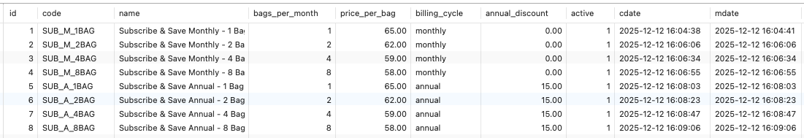

4.2.2 lce_user_subscriptions
Per-customer subscription.
CREATE TABLE lce_user_subscriptions (
id INT AUTO_INCREMENT PRIMARY KEY,
user_id INT NOT NULL,
plan_id INT NOT NULL, -- FK to lce_subscription_plans
status ENUM('pending','active','paused','cancelled', ‘upgraded’) NOT NULL DEFAULT 'active',
billing_cycle ENUM('monthly','annual') NOT NULL,
start_date DATE NOT NULL,
end_date DATE NOT NULL,
next_renewal_date DATE NOT NULL,
bags_plan_period INT NOT NULL, -- per month, from plan
bags_plan_total INT NOT NULL, -- total, 1,12,24,...
bags_plan_balance INT NOT NULL DEFAULT 0, -- total minus used bags
bags_plan_used INT NOT NULL DEFAULT 0, -- used since beginning
bags_available INT NOT NULL DEFAULT 1, -- available now
created_via ENUM('web','intra','other') DEFAULT 'web',
payment_last DECIMAL(10,2) DEFAULT 0.00,
payment_discount DECIMAL(10,2) DEFAULT 0.00,
payment_balance DECIMAL(10,2) DEFAULT 0.00, -- payment_last minus used
notes TEXT,
cdate DATETIME,
mdate DATETIME,
INDEX idx_user_id (user_id),
INDEX idx_status (status)
);

4.2.3 lce_subscription_bag_usage
Tracks bag usage per subscription per period.
CREATE TABLE lce_subscription_bag_usage (
id INT AUTO_INCREMENT PRIMARY KEY,
user_subscription_id INT NOT NULL,
invoice_id INT NULL,
pickup_id INT NULL,
bags_used INT NOT NULL DEFAULT 1, -- used for this pickup
cdate DATETIME,
mdate DATETIME,
INDEX idx_user_sub_period (user_subscription_id, period_start, period_end)
);

4.2.4 lce_user_credits
Handles credits (like the $20 new-user credit) and other account credits.
CREATE TABLE lce_user_credits (
id INT AUTO_INCREMENT PRIMARY KEY,
user_id INT NOT NULL,
type ENUM('welcome','promo','manual','refund') NOT NULL,
description VARCHAR(255) NOT NULL,
amount DECIMAL(10,2) NOT NULL,
balance DECIMAL(10,2) NOT NULL,
expires_at DATETIME NULL,
used TINYINT(1) NOT NULL DEFAULT 0,
cdate DATETIME,
mdate DATETIME,
INDEX idx_user (user_id)
);

The billing logic will subtract from lce_user_credits.balance before charging payment method.

4.3 Changes / Extensions to Existing Tables

4.3.1 lce_user_pickup (Orders)
Add fields for subscription vs PPO and meta:
- order_type ENUM('PPO','subscription','business') – differentiate service model.
- subscription_bags INT – number of bags in this pickup for subscription.
- subscription_period_start / subscription_period_end DATE – for linking usage.
- subscription_overweight_lbs DECIMAL(10,2).
- subscription_overweight_charge DECIMAL(10,2).
- subscription_bag_capacity_lbs DECIMAL(10,2).
PENDING TO DEFINE

4.3.2 lce_user_invoice & lce_user_invoice_line
Existing columns handle most needs (sub_total, promo_amount, etc.) but add:
- order_type (same enum as above).
- subscription_id (FK to lce_user_subscriptions) for invoices containing subscription charge.
- is_subscription_invoice TINYINT(1).
Invoice lines:
- Use type to distinguish:
  - WF, DC, HD, FEE_PND, FEE_SERVICE, SUBSCRIPTION_BAG, SUB_OVERWEIGHT_LBS etc.
PENDING TO DEFINE

4.3.3 lce_user_info
Add fields:
- default_order_type ENUM('PPO','subscription') – what to preselect.
- subscription_id (optional pointer to current lce_user_subscriptions.id).
PENDING TO DEFINE

5. Business Logic

5.1 Welcome Credit ($20)
- Triggered when:
- New user signs up via web with email/Google/Apple.
- Implementation:
  - Create lce_user_credits row:
    - type='welcome'.
    - amount=20.
    - balance=20.
- Usage:
  - During invoice creation for first PPO or subscription order:
    - Deduct from balance, mark credit as partially/fully used.
    - Support multiple credits (e.g., promo + welcome).

5.2 PPO Pricing Logic
Given:
- weight_lbs (sum of all W&F weight in order).
- PPO_rate_per_lb (from config table lce_configurations or lce_prices).
- pn_d_fee and service_fee from config.
- minimum_laundry_amount_usd = 30.
Algorithm:
- wf_amount = max(weight_lbs * rate_per_lb, minimum_laundry_amount_usd).
- order_base_total = wf_amount + pnd_fee + service_fee.
- Add price-list based items (DC, HD, LP) as additional invoice lines.
- Apply credits/promos.
- Store totals in lce_user_invoice and line details in lce_user_invoice_line.

5.3 Subscription Create New
For subscription CREATE (if CC on file and successful charge of payment amount):
Monthly | Yearly
TABLE: lce_user_subscriptions  INSERT  user_id: 117530  plan_id: 1  status: active  billing_cycle: 'monthly'  start_date: '2025-12-12'  end_date: '2026-01-12'  next_renewal_date: '2026-01-12'  bags_plan_period: 1  bags_plan_total: 1  bags_plan_balance: 1  bags_available: 1  payment_last: {amount}  payment_discount: 0.00  payment_balance: {amount}  mdate: NOW()  cdate: NOW()  AMOUNT:  bags_per_month * price_per_bag | TABLE: lce_user_subscriptions  INSERT  user_id: 117530  plan_id: 5  status: active  billing_cycle: 'yearly'  start_date: '2025-12-12'  end_date: '2026-12-12'  next_renewal_date: '2026-12-12'  bags_plan_period: 1  bags_plan_total: 12  bags_plan_balance: 12  Bags_available: 1  payment_last: {amount}  payment_discount: {discount}  payment_balance: {amount}  mdate: NOW()  cdate: NOW()  AMOUNT:  (bags_per_month * 12 * price_per_bag) * (100 - annual_discount) / 100  DISCOUNT:  (bags_per_month * 12 * price_per_bag) * (annual_discount) / 100
TABLE: lce_user_transactions  INSERT  user_id: 117530  Type: Debit  subscription_id: 12345  transactionId = {cc_trans_id}  Name: Credit Card  amount: {amount}  description: Subscription Payment  mdate: NOW()  Cdate: NOW()  AMOUNT:  bags_per_month * price_per_bag | TABLE: lce_user_transactions  INSERT  user_id: 117530  Type: Debit  subscription_id: 12345  transactionId = {cc_trans_id}  Name: Credit Card  amount: {amount}  description: Subscription Payment  mdate: NOW()  Cdate: NOW()  AMOUNT:  (bags_per_month * 12 * price_per_bag) * (100 - annual_discount) / 100

For subscription CREATE (no CC on file):
Monthly | Yearly
TABLE: lce_user_subscriptions  INSERT  user_id: 117530  plan_id: 1  status: pending  billing_cycle: 'monthly'  start_date: '2025-12-12'  end_date: '2026-01-12'  next_renewal_date: '2026-01-12'  bags_plan_period: 1  bags_plan_total: 1  bags_plan_balance: 0  payment_last: 0  payment_balance: 0  mdate: NOW()  cdate: NOW() | TABLE: lce_user_subscriptions  INSERT  user_id: 117530  plan_id: 5  status: pending  billing_cycle: 'yearly'  start_date: '2025-12-12'  end_date: '2026-12-12'  next_renewal_date: '2026-12-12'  bags_plan_period: 1  bags_plan_total: 12  bags_plan_balance: 0  payment_last: 0  payment_balance: 0  mdate: NOW()  cdate: NOW()

5.4 Subscription Cancel
For subscription CANCEL:
Monthly | Yearly
TABLE: lce_user_subscriptions  UPDATE  id = 12345  status: cancelled  mdate: NOW() | TABLE: lce_user_subscriptions  UPDATE  id = 12345  status: cancelled  mdate: NOW()
TABLE: lce_user_transactions  INSERT  user_id: 117530  Type: Debit  subscription_id: 12345  transactionId = {cc_trans_id}  Name: Credit Card  amount: {refund}  description: Subscription Refund  mdate: NOW()  Cdate: NOW()  REFUND:  if payment_balance > 0.00  and NOW() - start_date < 5 days  refund = payment_balance | TABLE: lce_user_transactions  INSERT  user_id: 117530  Type: Debit  subscription_id: 12345  transactionId = {cc_trans_id}  Name: Credit Card  amount: {refund}  description: Subscription Refund  mdate: NOW()  Cdate: NOW()  REFUND:  if payment_balance > 0.00  and NOW() - start_date < 5 days  refund = payment_balance  if payment_balance > 0.00  and NOW() - start_date > 5 days  refund = max(0, payment_balance - 100.00)

5.5 Subscription Upgrade/Downgrade
For subscription upgrade and downgrade:
Monthly | Yearly
TABLE: lce_user_subscriptions  UPDATE  id = 12345  status: upgraded  mdate: NOW() | TABLE: lce_user_subscriptions  UPDATE  id = 12345  status: upgraded  mdate: NOW()
TABLE: lce_user_subscriptions  INSERT  user_id: 117530  plan_id: 1  status: active  billing_cycle: 'monthly'  start_date: '2025-12-20'  end_date: '2026-01-20'  next_renewal_date: '2026-01-20'  bags_plan_period: 1  bags_plan_total: 1  bags_plan_balance: 1  bags_available: 1  payment_last: {amount}  payment_discount: 0.00  payment_balance: {amount}  mdate: NOW()  cdate: NOW()  AMOUNT:  max(0,(bags_per_month * price_per_bag) - previous_sub->payment_balance)  (Before max) positive: Charge CC  (Before max) negative: Refund | TABLE: lce_user_subscriptions  INSERT  user_id: 117530  plan_id: 5  status: active  billing_cycle: 'yearly'  start_date: '2025-12-20'  end_date: '2026-12-20'  next_renewal_date: '2026-12-20'  bags_plan_period: 1  bags_plan_total: 12  bags_plan_balance: 12  Bags_available: 1  payment_last: {amount}  payment_discount: {discount}  payment_balance: {amount}  mdate: NOW()  cdate: NOW()  AMOUNT:  max(0,((bags_per_month * 12 * price_per_bag) * (100 - annual_discount) / 100) - previous_sub->payment_balance)  (Before max) positive: Charge CC  (Before max) negative: Refund  DISCOUNT:  max(0,((bags_per_month * 12 * price_per_bag) * (annual_discount) / 100) - previous_sub->payment_balance)
TABLE: lce_user_transactions  INSERT  user_id: 117530  Type: Debit  subscription_id: 12345  transactionId = {cc_trans_id}  Name: Credit Card  amount: {refund}  description: Subscription Refund  mdate: NOW()  Cdate: NOW()  REFUND:  abs((bags_per_month * price_per_bag) - previous_sub->payment_balance) | TABLE: lce_user_transactions  INSERT  user_id: 117530  Type: Debit  subscription_id: 12345  transactionId = {cc_trans_id}  Name: Credit Card  amount: {refund}  description: Subscription Refund  mdate: NOW()  Cdate: NOW()  REFUND:  abs((bags_per_month * 12 * price_per_bag) * (100 - annual_discount) / 100) - previous_sub->payment_balance))

Subscription Logic
- Determine refund amount for current subscription:
- bags_included = plan.bags_per_month + banked_bags.

- When a pickup is processed:
    - bags_used += bags_this_pickup.
    - If bags_used <= bags_included:
    - No extra bag charge (the bag is “included”).
    - If bags_used > bags_included:
    - bags_extra = bags_used - bags_included (excess).
    - Extra bags charged at plan.price_per_bag.
- For overweight:
  - If any bag weight > bag_capacity_lbs:
    - overweight_lbs = sum(max(0, bag_weight - bag_capacity_lbs)).
    - Charge overweight_lbs * PPO_rate_per_lb.
- Banking:
  - At period end:
    - unused_bags = bags_included - bags_used (if positive).
    - Add to bags_bank_balance.
- Invoicing:
  - Create invoice lines:
    - type='SUBSCRIPTION_BAG' with count = bags_used_in_period (or aggregated per month).
    - type='SUB_OVERWEIGHT_LBS' with quantity = overweight_lbs, price per lb.

5.4 Annual Subscription Billing
- When user chooses annual billing:
  - Compute:
    - annual_total = monthly_price_per_bag * bags_per_month * 12.
    - discounted_price = annual_total * (1 - 0.15).
  - Charge once (create invoice & transaction).
  - Set annual_paid=1, next_renewal_date = start_date + 12 months.
- Cancellation:
  - Calculate unused portion (remaining months).
  - Refund = unused_portion - max(0.15 * original_amount, $100).
  - Create negative invoice/credit.

6. Users Backend (Admin / CSR Portal)

7.1 Purpose
Internal web app for:
- Customer service reps (CSR).
- Operations staff.
- Accounting / finance.
- Sales for business services.

7.2 Authentication & Roles
- Reuse f29om_users with roles assigned via:
  - New table lce_user_roles or use existing params JSON/ACL.
- Roles:
  - CSR, Operations, Accounting, Admin.

7.3 Screens

7.3.1 Dashboard
- KPIs:
  - Today's pickups/deliveries.
  - Orders by status.
  - New vs returning customers.
  - Subscription metrics (active subs, bag usage).
- Quick links:
  - Search customer.
  - Add manual credit.
  - Create CS ticket.

7.3.2 Customer Search
- Filter by:
  - Name, email, phone.
  - ZIP, city, group.
  - Subscription status.
- Results:
  - Basic info with icons for active sub, recurring schedule, vacation, etc.

7.3.3 Customer Detail View
Tabs:
- Overview
  - Contact info, address, zone details.
  - Subscription summary.
  - Recurring schedule + vacation status.
  - Active credits.
- Orders / Pickups
  - List lce_user_pickup records.
  - For each:
    - Pickup & delivery timestamps.
    - Weight, items, site, driver.
    - Link to invoice.
- Invoices
  - List lce_user_invoice.
  - Show status, amount, discounts, promos.
- Transactions
  - lce_user_transactions and lce_payment entries.
- Subscription
  - Current plan, bag usage details (from lce_subscription_bag_usage).
  - Buttons:
    - Change plan.
    - Pause / Resume.
    - Cancel subscription.
    - Apply manual bag credits.
- Preferences & Comms
  - From lce_user_info:
    - Laundry preferences.
    - Driver/laundry instructions.
  - From lce_communication_settings:
    - Opt-in/out for SMS/email per event type.
- CS Tickets
  - lce_user_cs & lce_user_cs_log.
  - Add CS note, change status.

7.3.4 Group / Business Management
- List all group admins (lce_user_group_admin).
- Drill into:
  - Members (lce_user_group_members).
  - Transaction history (lce_user_group_members_history).
  - Group-level limits & pricing.

7.3.5 Pricing Management
- Manage lce_prices_lists & lce_prices:
  - UI to edit price list names, default per-zip.
  - Manage items (SKU, type, name, description, prices).
- Manage lce_subscription_plans:
  - Add/edit plans, per-bag price, bag count, annual discount.

7.3.6 Scheduling & Operations
- Calendar view:
  - Pickups/deliveries by zone and driver.
- Manage:
  - lce_pickup_zones – add/edit ZIPs, days, geometry.
  - lce_pickup_nonworking_days – non-working dates by area.
  - lce_processing_sites – assign price lists to sites.

7.3.7 Promo & Credit Management
- Manage lce_promo_codes:
  - Types: percent, fixed amount, subscription-limited, etc.
- Issue manual credits:
  - Create lce_user_credits entry.
  - Choose type and optional expiry.

8. Migration & Backwards Compatibility

8.1 User & Order Data
- Existing users in f29om_users and lce_user_info remain valid.
- For existing orders:
  - order_type default = PPO.
- Historical behavior of fees and pricing remains unaffected.

8.2 Subscription Introduction
- Initially, lce_subscription_plans can be populated with:
  - 1/2/4/8 bag monthly plans only.
- lce_user_subscriptions will be empty and filled as new users subscribe.

8.3 Configurations
- Use lce_configurations to store:
  - PPO per-lb rate.
  - Minimum laundry charge.
  - P&D and service fees.
  - Bag capacity threshold.
  - Daily cutoff times for scheduling.
- These configurations will be read by API services instead of hardcoding values.

9. Non-Functional Requirements

9.1 Security
- Passwords stored hashed (e.g., bcrypt/argon2).
- All auth/API endpoints via HTTPS.
- PCI-compliant card storage via payment gateway; no raw card numbers in DB.
- RBAC for Users Backend.

9.2 Logging & Analytics
- Log key events:
  - Signup, login.
  - Pickup created/updated.
  - Subscription created/cancelled.
  - Payments and refunds.
- Instrument front-end for analytics (GA4, etc.) with events like:
  - signup_started, signup_completed, order_scheduled, sub_selected, sub_cancelled.

9.3 Performance & Scalability
- Indexes:
  - user_id on all user-related tables (lce_user_pickup, lce_user_invoice, lce_user_transactions, etc.).
  - Composite indexes for subscription period queries.
- All queries must be written in a way that supports growth to tens of thousands of active users.

10. Implementation Checklist (High-Level)
- Database
  - Create new tables: lce_subscription_plans, lce_user_subscriptions, lce_subscription_bag_usage, lce_user_credits.
  - Apply ALTERs to existing tables for fields described above.
  - Seed initial configuration and subscription plans.
- Backend APIs
  - Implement auth, address, zone, scheduling, pricing, subscription, billing APIs as specified.
  - Integrate with payment provider.
  - Add credit consumption logic to invoice creation.
- Web Frontend
  - Implement new navigation and pages:
    - Home (with pop-up promo and video).
    - Services & Prices.
    - Subscribe & Save Savings.
    - Business Services.
  - Implement 3-step signup + scheduling flow.
  - Logged-in dashboard with subscription & order management.
- Users Backend
  - Implement separate SPA (or module) with:
    - Dashboard.
    - Customer search & detail.
    - Group management.
    - Pricing & plan management.
    - Scheduling calendar.
    - Promo & credit management.
    - CS ticket console.
- Testing
  - Unit tests for pricing and subscription logic (bag usage, overages, banking).
  - Integration tests for the 3-step flow and subscription change cancellations.
  - End-to-end tests for scheduling and invoice generation.

